PUBLIC NOTICE

STATE OF TEXAS §
COUNTY OF JOHNSON §
TOWN OF CROSS TIMBER §

NOTICE IS HEREBY GIVEN THAT THE BOARD OF ALDERMEN OF CROSS TIMBER, TEXAS, WILL CONDUCT A REGULAR MEETING ON THURSDAY, MAY 14, 2026 AT 6:30 P.M. IN THE BRIAROAKS FIRE HALL LOCATED AT 515 WARD LANE, IN THE CITY OF BRIAROAKS, TEXAS.

AGENDA
- Call to Order
- Review procedure for addressing the Board and Open Meetings Act
- Roll Call
- Review and approve Minutes of the April 2, 2026 meeting.
- Review and approve Financial Records for March & April 2026.
- Give oaths and complete paperwork for new Aldermen.
- Public Comment
- Committee Reports:
A. Capital Improvements Committee
B. Infrastructure Committee
C. Zoning Committee
D. Social Events Committee
- Discussion and possible action on 2024-2025 town audit results.
- Discussion and possible action on 3015 FM 731 nuisance property
- Discussion and possible action on excavation ordinance feedback from TOASE
- Discussion and possible action on Administrative Waiver – McCoy build
- Discussion and possible action how zoning and subdivision platting affect each other and variances allowed.
- Discussion and possible action on town secretary position.
- Announcements
- Request for future agenda items
- Adjournment

NOTICE
The Board reserves the right to the following:
Items do not have to be considered in the same order as shown on this Agenda.
The Board may continue its deliberations to the next calendar day, if it deems it necessary.

Pursuant to Section 551.071, Texas Government Code: The Board reserves the right to adjourn into Executive Session to seek the advice of the city attorney regarding any item on the agenda, pending or contemplated litigation, or a settlement offer.

I, Patti Meier, Mayor, do certify that the above agenda was posted on May 8, 2026, by 6:00 P.M. on the secure storage building, 3225 Cross Timber Road.
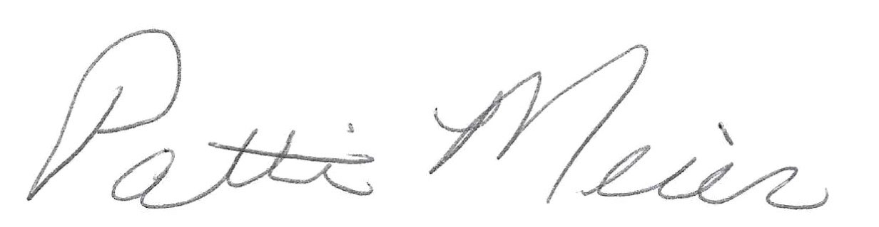
Patti Meier, Mayor

