-*
PUBLIC NOTICE

STATE OF TEXAS §
COUNTY OF JOHNSON §
TOWN OF CROSS TIMBER §

NOTICE IS HEREBY GIVEN THAT THE BOARD OF ALDERMEN OF CROSS TIMBER, TEXAS, WILL CONDUCT A SPECIAL MEETING ON THURSDAY, MAY 15, 2024 AT 7:00 P.M. IN THE BRIAROAKS FIRE HALL LOCATED AT 515 WARD LANE, IN THE CITY OF BRIAROAKS, TEXAS.

AGENDA
1. Call to Order
2. Review procedure for addressing the Board and Open Meetings Act
3. Roll Call
4. Review and approve Minutes of the March 14, 2024 meeting.
5. Review and approve Financial Records for March & April 2024.
6. Canvas the May 4, 2024 election
7. Give oaths and complete paperwork for new positions.
8. Public Comment
9. Committee Reports:
A. Capital Improvements Committee
B. Infrastructure Committee
10. Discussion and possible action on town property external improvements to secure storage including: paint, siding, landscaping, locking mailbox and cement pad
11. Discussion and possible action on town property internal improvements to secure storage including: UCS Fiber connection, desk, table, cleaning supplies and labor to move files
12. Discussion and possible action on purchasing town property fence
13. Discussion and possible action flood planning information visit by NCTCOGs Environment and Development Department.
14. Discussion and possible action on nuisance ordinance.
15. Discussion and possible action on investing or dividing town funds for FDIC protection
16. Discussion and possible action on removal of two dead trees on town property.
17. Announcements
18. Request for future agenda items
19. Adjournment

NOTICE
The Board reserves the right to the following:
Items do not have to be considered in the same order as shown on this Agenda.
The Board may continue its deliberations to the next calendar day, if it deems it necessary.

Pursuant to Section 551.071, Texas Government Code: The Board reserves the right to adjourn into Executive Session to seek the advice of the city attorney regarding any item on the agenda, pending or contemplated litigation, or a settlement offer.

I, Patti Meier, Mayor, do certify that the above agenda was posted on May 11, 2024, by 7:00 P.M. on the door of the Briaroaks Fire Hall, 515 Ward Lane, Briaroaks, Texas.

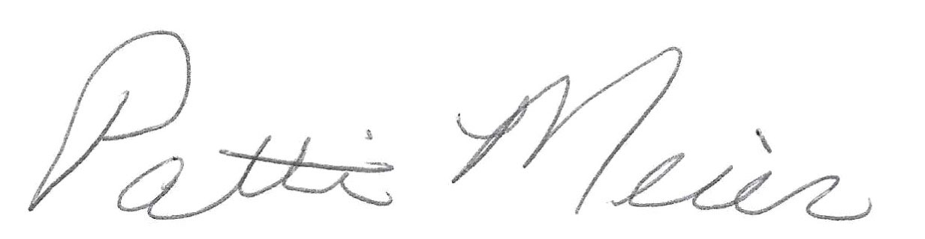
_______________________________________
Patti Meier, Mayor

